In secure systems, authentication and authorization are two critical mechanisms to protect resources and ensure only legitimate clients have access. Here's a detailed breakdown:

1. Authentication vs Authorization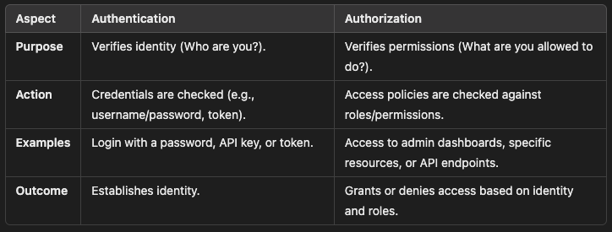

2. Authentication Methods

2.1 Client Authentication
This process ensures that the client accessing the resource is legitimate.
Common Methods:
- API Keys:
  - Clients include a unique key in requests.
  - Example:
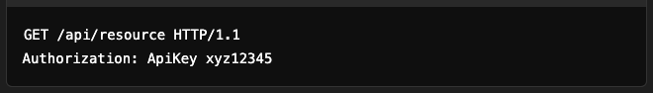
- OAuth 2.0 Client Credentials:
  - Used for machine-to-machine authentication.
  - Client uses client_id and client_secret to get an access token.
  - Example:
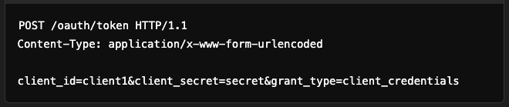
- Mutual TLS:
  - Both client and server authenticate using certificates.
- JWT (JSON Web Token):
  - Client sends a signed token with each request.
  - Example:


2.2 Resource Authentication
Ensures the resource being accessed is valid and belongs to the authenticated client.
Approach:
- Validate the token or key associated with the resource request.
- Example:
  - Validate a signed URL for an S3 bucket file download.

3. Authorization Methods

3.1 Role-Based Access Control (RBAC)
- Permissions are assigned to roles (e.g., Admin, User).
- Roles are assigned to users/clients.
- Example:
  - Admin can delete a resource, but a User can only view it.

3.2 Attribute-Based Access Control (ABAC)
- Permissions are based on attributes like user location, time, and device.
- Example:
  - A user can access data only during working hours.

3.3 Policy-Based Access Control
- Access is governed by predefined policies.
- Example:
  - AWS IAM policies define actions and resources that are allowed.

3.4 Token-Based Authorization
- Use tokens like JWT to embed claims (e.g., roles, permissions).
- Server validates the token and checks embedded claims.

4. OAuth 2.0 for Authentication and Authorization

4.1 Key Components:
- Resource Owner:
  - The user who owns the data.
- Client:
  - Application requesting access to resources.
- Authorization Server:
  - Issues tokens after authentication.
- Resource Server:
  - Validates tokens and serves the resource.

4.2 Common OAuth 2.0 Flows:
- Authorization Code Flow (for user authentication):
  - User logs in to an authorization server.
  - A code is exchanged for an access token.
- Client Credentials Flow (for machine-to-machine):
  - Client gets a token using client_id and client_secret.

5. Implementation Example

5.1 Authentication (Spring Security Example)
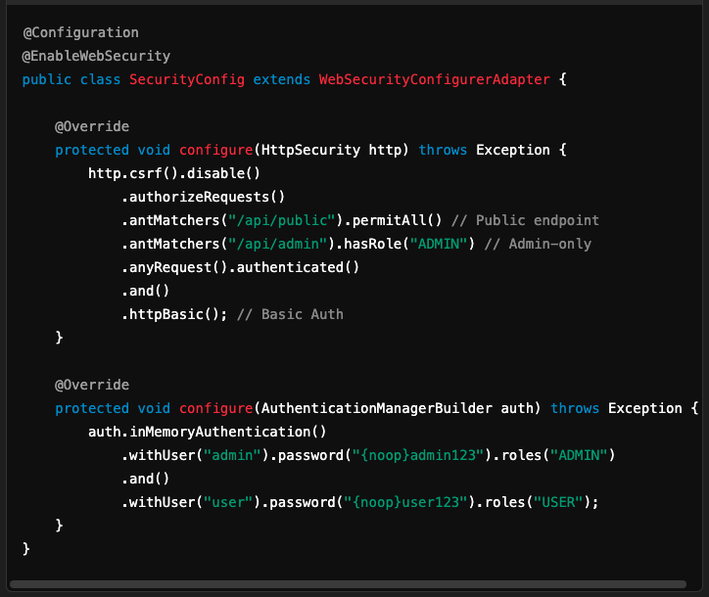

5.2 Authorization with JWT
- Generate a JWT:
  - Example payload:
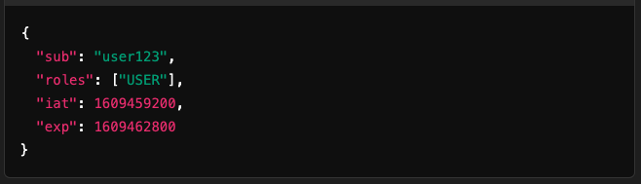
- Validate JWT:
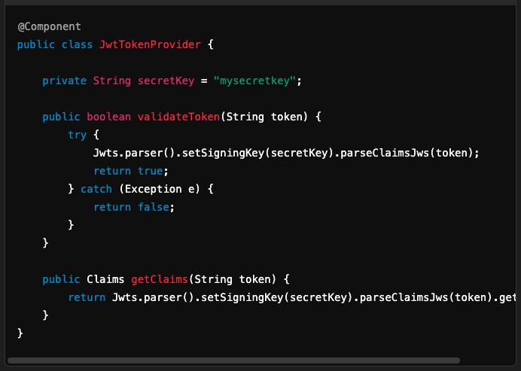

6. Security Best Practices
- Use HTTPS:
  - Encrypt all communication between clients and servers.
- Token Expiry:
  - Set short lifetimes for tokens and support refresh tokens.
- Least Privilege Principle:
  - Assign minimal permissions required to perform actions.
- Rate Limiting:
  - Limit API calls to prevent abuse (e.g., DDoS).
- Logging and Monitoring:
  - Log authentication and authorization events for auditing.

This design ensures a robust and scalable system for resource and client authentication and authorization.

